

# Cse 326

# SYNOPSIS

Project name:

Online real estate business

GROUP MEMBER:

Muneer Basha RK19SJB58 11917807

Vishnu Vardhan RK19SJB59 11902387

ARKAPRIYA DE RK19SJB60 11902078

**Submitted to: Sukhvir Kaur**

## **Introduction**

# **Websites:**

A website is a group of web pages that have information in the various pages that contain similar subject materials. For instance, the web site would have a name (subject) such as GoodFords.com and have several pages related to good Ford vehicles. The website has a main web page commonly called the Homepage (index.html or default.html). The site's address will display the homepage and you can click on hyperlinks to go to other pages on the website. A webpage is a text page written in a form of HTML (hyper text mark up language) that contains text, links or tags that will display graphics, audio, video, downloadable files and of course other web pages.

# **Online real estate website:**

Internet real estate is the concept of publishing housing estates for sale or rent, and for consumers seeking to buy or rent a property. Internet real estate surfaced around 1999 when technology advanced and statistics prove that more than 1 million homes were sold by the owners themselves in just America in 2000. Some of the prime internet real estate platforms include [**Zillow**](https://en.m.wikipedia.org/wiki/Zillow)**,**[**Trulia**](https://en.m.wikipedia.org/wiki/Trulia)**,**[**Yahoo! Real Estate**](https://en.m.wikipedia.org/wiki/Yahoo!_Real_Estate)**,**[**Redfin**](https://en.m.wikipedia.org/wiki/Redfin) and [**Realtor.com**](https://en.m.wikipedia.org/wiki/Realtor.com).

This website is an online real estate business website through which a user can access its information and manage all the adding, updating, deleting the assets and some of its tasks. The Admin user can change the update the information regarding property selling and buying . The system is very useful for the promoters who develop apartments, hotels, villa, residential properties and commercial properties. Companies or individual agents can also advertise their property.

## **Project Objectives:**

* Making an Online real estate website to help the companies or builders to post and edit their properties online and to manage their personal info/contact details for the same.
* The system is for the property buyers to view, analyse and compare different types of properties in one place.
* The system is also useful which also keeps track of Account details of buyers and Investors and also RES Industry.
* This website will also Obtaining a comparative market analysis for sellers.

# System Description:

* The system will have a login page where a login box should appear when the system is invoked. This system will have 2 types of users – Admin User & Generic User. Based on the user type, the authorization will vary as below.
* **Admin User**

The Admin should have all the type of authority. Like - create/add/remove users, Create/delete any property.

* + The Admin should maintain property. Admin identify property type as it is residential or commercial property.
  + These users will have the full control over the website.
* **Generic User** 
  + They will be able to view/publish new property**.**
  + These users should be able to book the property for sell or rent with detail of property.
* 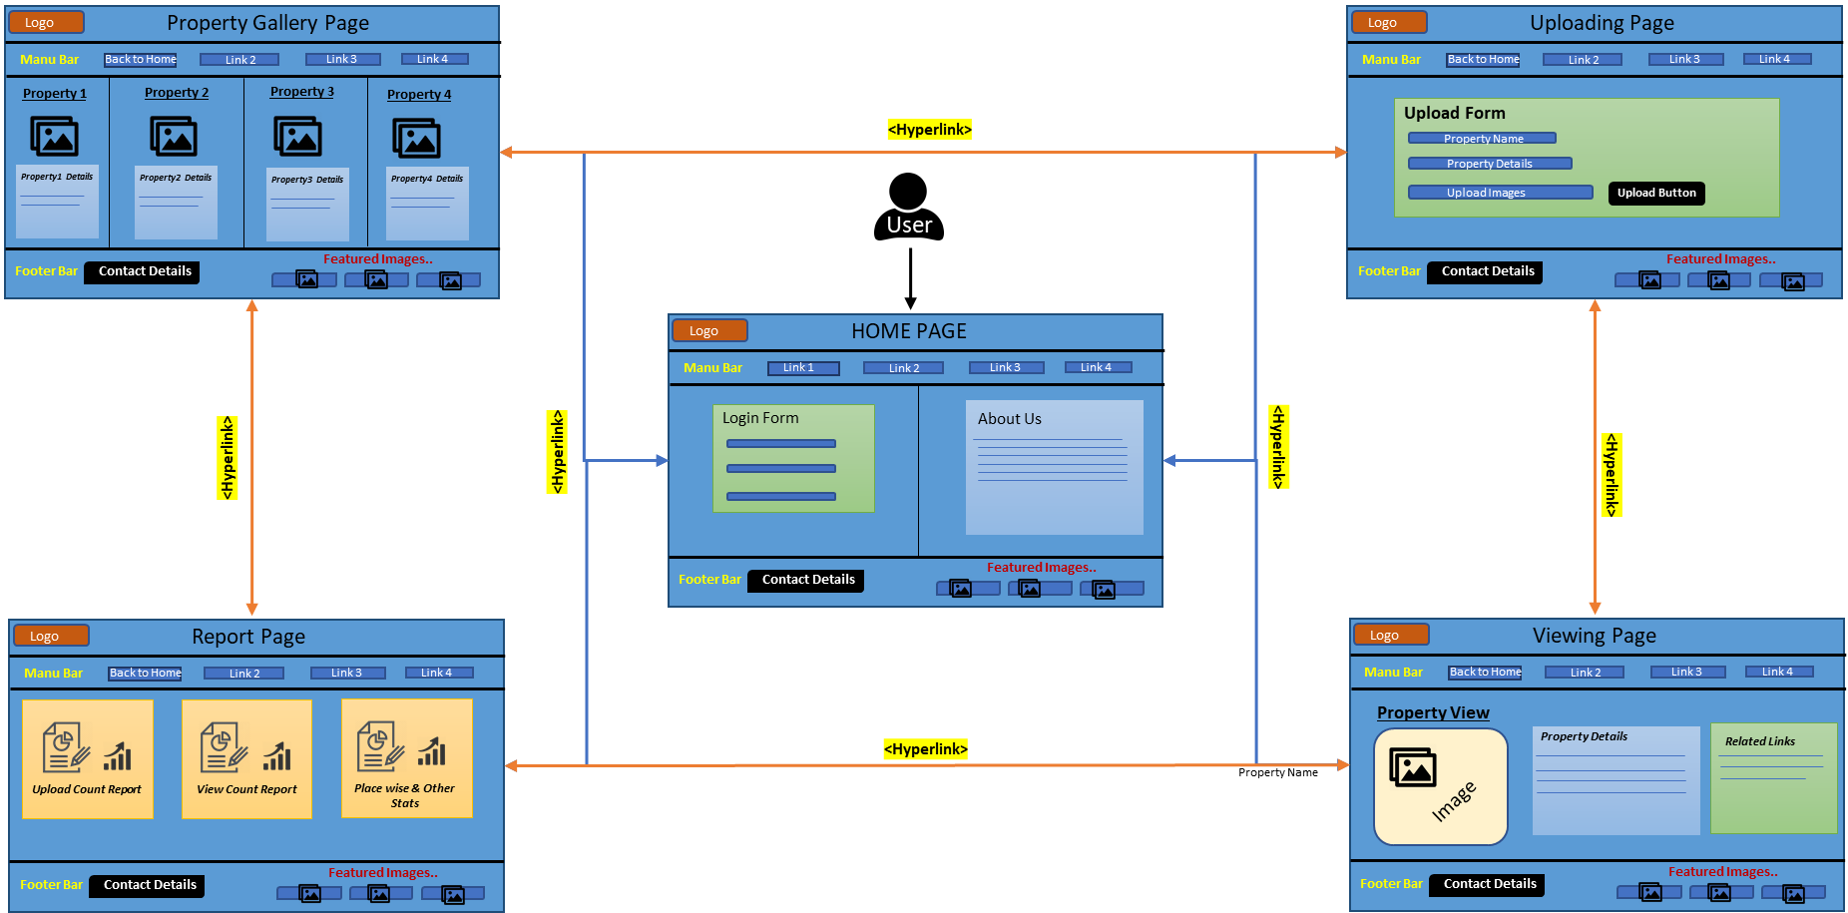**Website Blueprint**

# **Uploading page**:

* Once log in is successful it will be showing uploading page.
* This page will contain hyperlink to go to other pages including the link to go back to the page.
* User have to fill the uploading form including property name, property details and images.
* This page will contain a upload button. And User can upload any type of property details.

**Home page:**

* It will contain a Title.
* There will be a login form for users to login.
* This page will contain hyperlink to go to other pages in the Manu Bar.
* We will also share the history of our website and share all the details of our website.
* In the corner there will be a logo of our website.
* In the footer area, it will have some featured/highlighted property.
* It will also contain contact details in the footer.

# **Viewing page:**

* In this page the user can see various types of propery details.

# 

# **Viewing Page**

* This page will view the details and images of the flats, bungalow, rental, pgs. Where User can choose according to their needs.
* There will be related links of other websites also.
* This page will also contain hyperlink to go to other pages including the link to go back to the page.

# **Report page:**

* This page will contain upload count report and user can also view the other website statistics like – total Upload Count, place wise upload Statistics etc..
* This page will contain hyperlink to go to other pages including the link to go back to the page.

# **Gallery page :**

* This page will contain the images and videos of all the properties.
* There will be different type of property details and their images like – Location/name/locality etc.
* Also a property search option.
* This page will contain hyperlink to go to other pages including the link to go back to the page.

# **Conclusion:**

Reaching more customers online is a prerequisite in today's digital markets. Real estate professionals can use visual content to generate more leads online, but also improve customer engagement and bring more web traffic to their websites and social channels. Now people are also more interested in selling or buying their property through online so they provide their details to the websites, which -

**Saves time**: In the world where people don't have much time to go out searching for a home to buy or hire on rent, for them these property portals and listings are a boon. They can simply login to these portals and search for properties as per their needs.

**Faster means of searching a property**: Online searching is the fastest means of finding a suitable property. Within few minutes you can have a look at countless properties and also the deals are quicker.

**Wider reach**: Just by sitting on your PC you can garner information about properties in any part of the world with the help of these Real Estate websites.

# References:

* [**https://www.slideshare.net/divyeshsarkar/se-final-report**](https://www.slideshare.net/divyeshsarkar/se-final-report)
* [**https://www.irjet.net/archives/V5/i1/IRJET-V5I1203.pdf**](https://www.irjet.net/archives/V5/i1/IRJET-V5I1203.pdf)
* **https://en.wikipedia.org/wiki/Internet_real_estate**